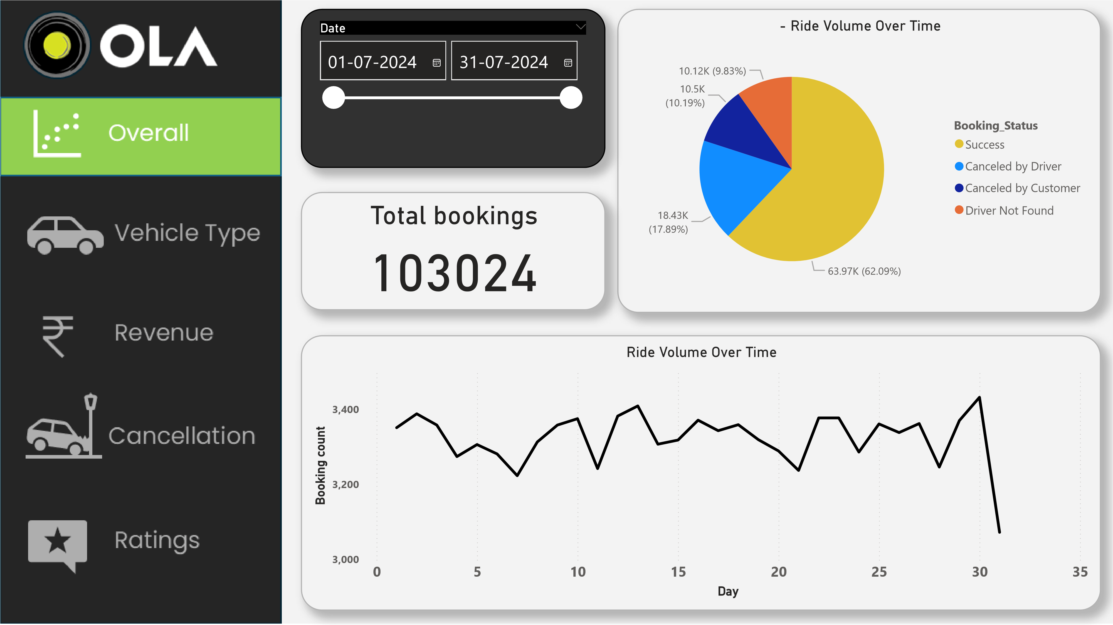
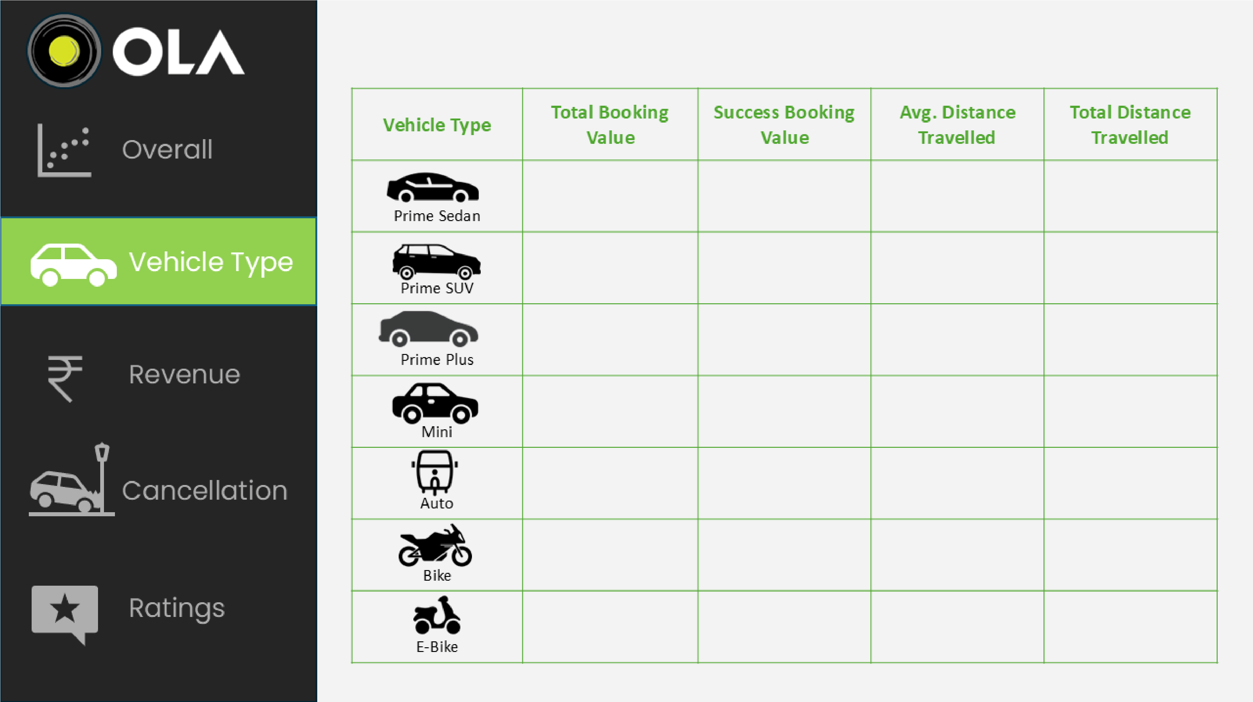
Power BI Desktop
4.88
M
5.02
M
4.89
M
5.05
M
M
4.97
M
5.05
8.30
M
7.93
M
8.05
M
7.99
M
8.09
M
M
7.99
M
8.18
5.22
M
25.01
24.88
25.03
24.98
10.04
24.93
25.15
K
235
K
224
K
227
K
226
92
K
228
K
231
K
Date

01-07-2024

31-07-2024

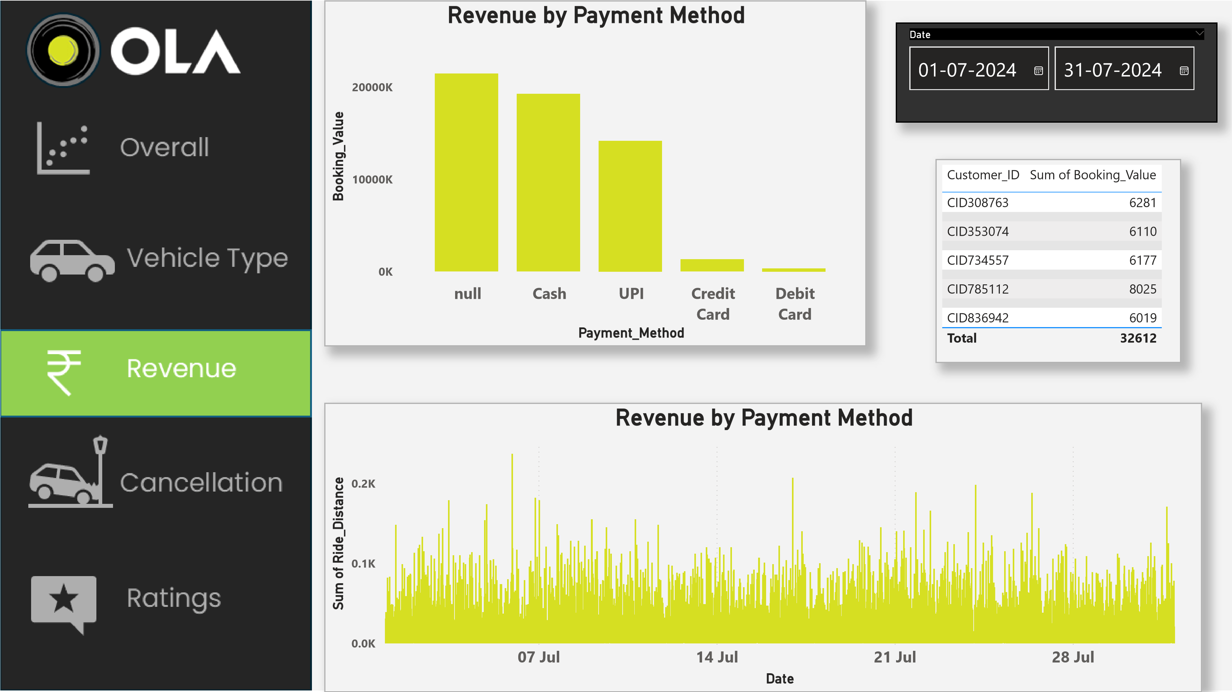
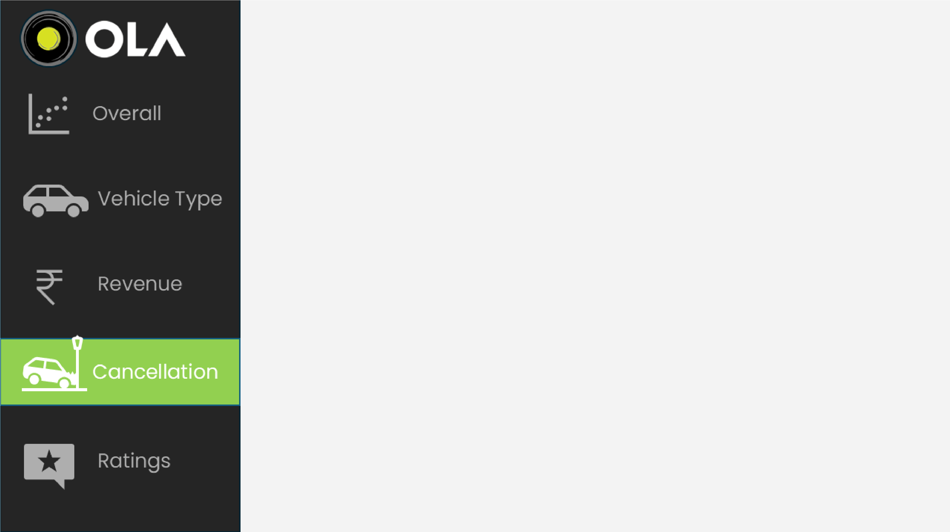
Power BI Desktop
Cancle Ride by Driver
)
K (35.49%
6.54
)
K (29.36%
5.41
(19.82%)
)
K (15.32%
2.83
K
3.65
Canceled_Rides_by_Dri…
Personal & Car relate…
Customer related issue
Customer was cough…
More than permitted…
Cancled Ride by Customer
3.18
K (30.24%
)
)
2.67
K (25.43%
2.08
K (19.82%
)
(14.93%)
)
K (9.57%
1.01
K
1.57
Canceled_Rides_by_Cus…
Driver is not moving …
Driver asked to cancel
Change of plans
AC is Not working
Wrong Address
Date

01-07-2024

31-07-2024

Total bookings
103024
Succeded bookings
63967
Canceled bookings
28933
Cancellation Rate
28.08
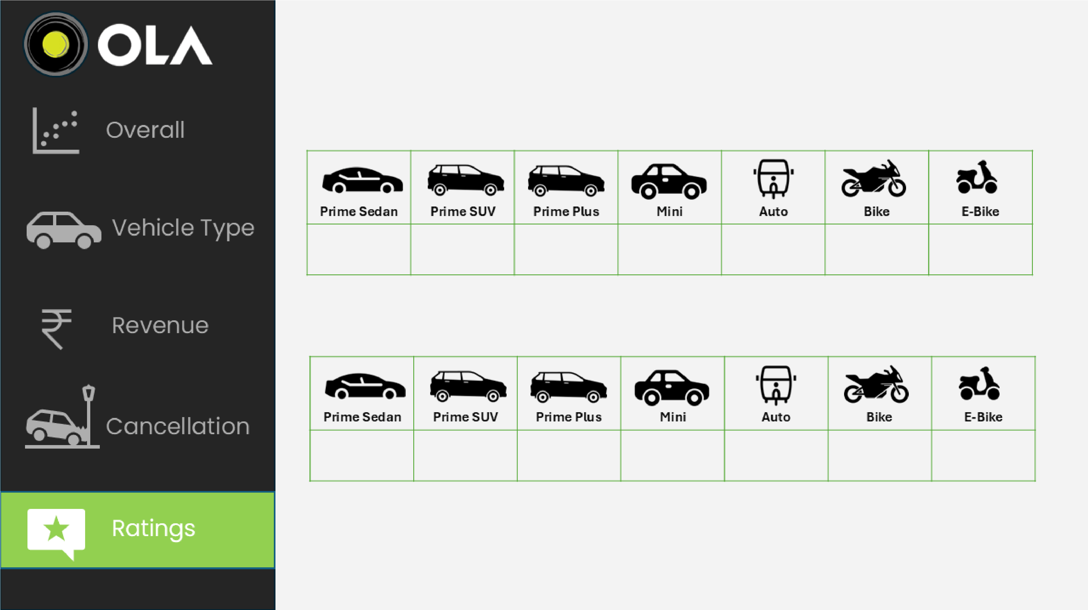
Power BI Desktop
3.99
4.01
3.99
4.00
4.01
4.00
4.01
4.00
Driver Rating
Customer Rating
4.00
4.01
4.00
4.00
3.99
3.99

